SMS System - User Interface
# Source: AI Source: Provided by: [Data Path: Persons Table -> ID Column: 1, Name_En Column: Motasem Essam] -> From: [ChatGPT] on [1/21/2026]
The User Interface is the front-end layer of an SMS system that allows users (humans or apps) to interact with the system to send, manage, or track SMS messages.

👨‍💻 What is the User Interface?
# Source: AI Source: Provided by: [Data Path: Persons Table -> ID Column: 1, Name_En Column: Motasem Essam] -> From: [ChatGPT] on [1/21/2026]
It's the visual or programmatic access point used to control the SMS system. It can be:
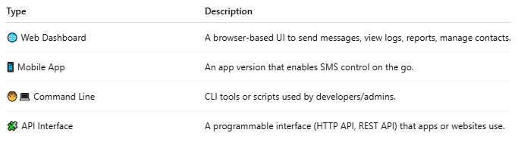
Type | Description
🌐 Web Dashboard | A browser-based UI to send messages, view logs, reports, manage contacts.
📱 Mobile App | An app version that enables SMS control on the go.
🧑‍💻 Command Line | CLI tools or scripts used by developers/admins.
🧩 API Interface | A programmable interface (HTTP API, REST API) that apps or websites use.

🛠️ Features of a Typical SMS System UI
# Source: AI Source: Provided by: [Data Path: Persons Table -> ID Column: 1, Name_En Column: Motasem Essam] -> From: [ChatGPT] on [1/21/2026]
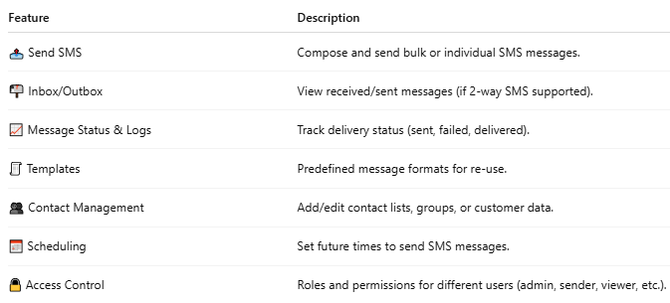

Feature | Description
📤 Send SMS | Compose and send bulk or individual SMS messages.
📬 Inbox/Outbox | View received/sent messages (if 2-way SMS supported).
📈 Message Status & Logs | Track delivery status (sent, failed, delivered).
🧾 Templates | Predefined message formats for re-use.
👥 Contact Management | Add/edit contact lists, groups, or customer data.
📅 Scheduling | Set future times to send SMS messages.
🔒 Access Control | Roles and permissions for different users (admin, sender, viewer, etc.).

📲 Example UI Tools
# Source: AI Source: Provided by: [Data Path: Persons Table -> ID Column: 1, Name_En Column: Motasem Essam] -> From: [ChatGPT] on [1/21/2026]
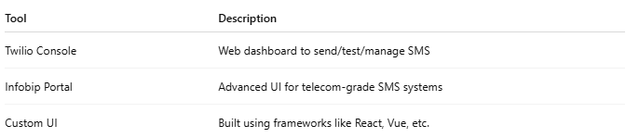

Tool | Description
Twilio Console | Web dashboard to send/test/manage SMS
Infobip Portal | Advanced UI for telecom-grade SMS systems
Custom UI | Built using frameworks like React, Vue, etc.

🧑‍💼 Who Uses It?
# Source: AI Source: Provided by: [Data Path: Persons Table -> ID Column: 1, Name_En Column: Motasem Essam] -> From: [ChatGPT] on [1/21/2026]
- Marketers → Send promotional campaigns
- Support teams → Alert users of tickets or updates
- Developers → Integrate APIs and monitor delivery
- Admins → Manage system settings, logs, limits

